Open Reduction with or without DEGA osteotomy in children with DDH before the age of two years.
M. O. Hegazi, M. Mashhour, A. Elgazzar, and M. A. Zahran
Orthopedic, Dept., Faculty of Medicine, Benha Univ., Benha, Egypt
E- Mail: mohamed.abdelbaky@fmed.bu.edu.eg
Abstract
Developmental Dysplasia of the hip is a common hip condition that affects around 1-3% of newly born children. Moreover, it is the main reason accounting for around 29% of primary hip replacements up to the sixties of age. The management of developmental dysplasia of the hip mainly tries to early diagnose, to start the treatment. Concentric reduction of the hip, and adequate coverage of the acetabular roof are the determinants of treatment whether the hip is in place, subluxated, or highly dislocated. Open reduction alone may provide persistent reduction for several years; however, the lack of adequate osseous roof over the femoral head would cause biomechanical problems in adulthood. In contrast, Dega osteotomy provides much better coverage and the final result would be more anatomical, which may prevent the child from developing further joint problems in the future. This study was carried out at Benha University Hospital on two groups as follows: Group A: 10 patients underwent open reduction with DEGA, Group B: 10 patients underwent open reduction without DEGA. Mean age of the study population was 21 months in group A, 19 months in group B. The affected side was right side (50.0%) while left side was 50.0%. The IHDI median of the two groups was grade 1 in group A, while it was grade 3 in group B. At 6 months, acetabular index was significantly higher in group B (49) compared to group A (38). P value was <0.001. There was no significant difference between both groups pre-operatively. Regarding dislocation, Dislocation was significantly higher in group B (50.0%) compared to group A (0.0). P value was 0.033.
- Keywords: DDH; open reduction + DEGA osteotomy; open reduction without DEGA osteotomy

- Introduction
Developmental dysplasia of the hip is a common hip condition that affects around 1-3% of newly born children. Moreover, it is the main reason accounting for around 29% of primary hip replacements up to the sixties of age (1).
DDH is considered a spectrum of pathology, that ranges from mild acetabular dysplasia with a stable hip up to more severe forms, which are associated with hip instability, with variable degrees of subluxation or even complete dislocation (2).
The screening programs effectiveness to early detect DDH are widely variable according to their operator, and diagnostic criteria. Delayed diagnosis results in much more complex treatment and increased complications and failure, so early diagnosis and proper management are essential. (3)
The management of developmental dysplasia of the hip mainly tries to early diagnose in order to start the treatment. Acetabular remodeling is thought to be the maximum at the first two years of life. After this age, satisfactory development cannot always be assured by non-operative treatment following closed reduction (4).
The ultimate goal in any of these is to provide a stable, congruent, and functional joint, preferably with normalized anatomy. (5,6)
One of the standard treatment methods for developmental dysplasia of the hip before the walking age is closed reduction followed by immobilization in a hip Spica cast (7).
In case of closed reduction failure to maintain reduced joint or the need of an extreme hip position to maintain the reduction such as excessive internal hip rotation in addition to increased hip abduction to maintain reduction, this is a message indicating that closed method is not suitable for this patient and closed reduction should be avoided to prevent the complications. (8)
The two main complications of developmental dysplasia of the hip (DDH) treatment are Avascular necrosis (AVN) and residual hip dysplasia. Although early reduction of the hip may decrease the incidence of residual dysplasia, it may increase the incidence of AVN in case of extreme hip joint position. (9)
Concentric reduction of the hip and adequate coverage of the acetabular roof are the determinants of treatment whether the hip is in place, subluxated, or highly dislocated.
Open reduction alone may provide persistent reduction for several years; however, the lack of adequate osseous roof over the femoral head would cause biomechanical problems in adulthood. In contrast, Dega osteotomy provides much better coverage and the final result would be more anatomical, which may prevent the child from developing further joint problems in the future. (10).
- Patients and methods
A case series randomized clinical study was done including twenty patients with DDH (ten cases managed by open reduction only – ten cases managed by open reduction and DEGA osteotomy) from December 2018 till December 2019 in orthopedic department, Benha university hospital. Patients were divided into two groups.
- Group I: Underwent posterior malleolus fixation with or without syndesmotic screw.
- Group II: Underwent conservative treatment with Syndesmotic screw.
-Inclusion criteria:
- Patients with idiopathic hip dislocation.
- less than two years in age.
- medically fit.
-Exclusion criteria:
- Patients who refused to join the study after explaining risks and benefits.
- Patients with hip dislocation other than DDH.
- Patients with DDH older than two years of age.
- Patients with DDH who had a previous surgical intervention.
- Patients who are medically unfit.
Preoperative evaluation.
Full history taking, complete clinical examination and Radiological evaluation; all patient were examined radiologically by Antero-posterior, Lateral radiographs.
Operative intervention
- The procedures were carried out under general anesthesia.
- Approach anterolateral approach.
- Open Reduction of the femoral head to the true acetabulum.
- Femoral de-rotation osteotomy.
- DEGA osteotomy in group A.
Post-operative evaluation
All patients were followed up for at least 6 months.
- X-ray at each follow-up, patients were assessed with AP, lateral.
- C.T. at the post-operative day one, and after 6 weeks.
Assessment of complications
Intraoperative, early post-operative and complication during the period of follow up recorded.
  - Statistical methods
Data management and statistical analysis were done using SPSS vs.25. (IBM, Armonk, New York, United states). Numerical data was summarized as means and standard deviations or medians and ranges. Categorical data was summarized as numbers and percentages.
Comparisons between both groups were done using Mann Whitney U test for numerical data. Categorical data was compared using Chi-square or Fisher’s exact test.
All P values were two sided. P values less than 0.05 were considered significant.
- Results
Mean age of the study population was 39 years with standard deviation of 9 years. 60.0% of the study population were males while only 40.0% were females. Smoking, diabetes and hypertension represented 20.0%, 10.0% and 10.0% respectively. The most frequent side was right side (60.0%) while left side was 40.0%. table1

Table (1) General characteristics in both groups
 |  |  | Group A  (n = 10) | Group B  (n = 10) | P value
Age (months) | Mean ±SD |  | 21 ±3 | 19 ±3 | 0.123
Gender | Males | n (%) | 0 (0.0) | 2 (20.0) | 0.474
 | Females | n (%) | 10 (100.0) | 8 (80.0)
Side | Left | n (%) | 7 (70.0) | 3 (30.0) | 0.074
 | Right | n (%) | 3 (30.0) | 7 (70.0)

There were no significant differences between both groups as regard age and gender. P value were 0.123 and 0.474.
There was no significant difference between both groups as regard site affected. P value was 0.074.

Table (2) IHDI grade in both groups at different time points
 |  | Group A  (n = 10) | Group B  (n = 10) | P value
Pre-operative | Median (range) | 4 (3 - 4) | 4 (3 - 4) | 0.342
Post-operative | Median (range) | 1 (1 - 1) | 1 (1 - 2) | 0.146
3 months | Median (range) | 1 (1 - 1) | 1 (1 - 2) | 0.146
6 months | Median (range) | 1 (1 - 1) | 3 (1 - 4) | 0.023

- At 6 months, IHDI grade was significantly higher in group B (3) compared to group A (1). P value was 0.023.
- There were no significant differences between both groups as regard IHDI grade at pre-operative time, immediate post-operative and 3 months. P values were 0.342, 0.146 and 0.146.

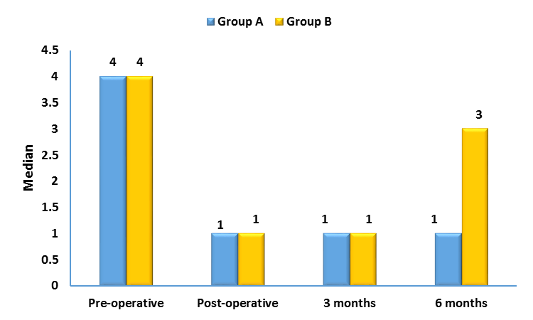
EFAS score
Fig (1) IHDI grade median in both groups

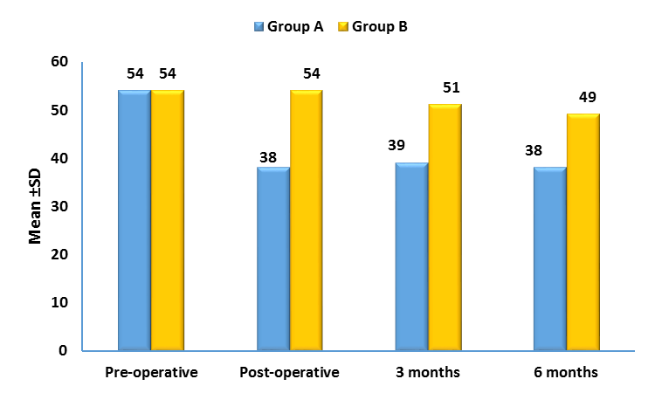
Fig (2) Acetabular Index Mean in both groups

- Acetabular index was significantly higher in group B (54) compared to group A (38) immediate post-operative. P value was <0.001
- At 3 months, acetabular index was significantly higher in group B (51) compared to group A (39). P value was <0.001
- At 6 months, acetabular index was significantly higher in group B (49) compared to group A (38). P value was <0.001
There was no significant difference between both groups pre-operatively.

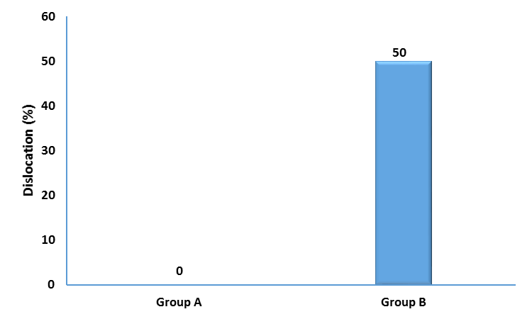
Fig (3) Post-operative dislocation

- Dislocation was significantly higher in group B (50.0%) compared to group A (0.0). P value was 0.033.

Table (3) Complications in both groups
Complications |  |  | Group A  (n = 10) | Group B  (n = 10) | P value
Dislocation |  | n (%) | 0 (0.0) | 5 (50.0) | 0.033
AVN |  | n (%) | 0 (0.0) | 0 (0.0) | NA

- Discussion
The main goal of the treatment is to have a congruent and concentrically reduced hip, to prevent early arthritic changes of the hip.
The choice of treatment for DDH depends on the patient’s age and the hip specific pathologic conditions. The age by which acetabular osteotomy could safely be done is still a matter of argument, however, it is generally accepted that DDH in a child around the walking age should be treated with acetabuloplasty. (11)
In the study done by Yilar et al., results raised the concerns about the increase in the rate of revision surgery in the cases who didn’t have pelvic osteotomy. (12)
In their review, Kothari et al. reported a 56% revision surgery rate in OR patients compared with 11% revision surgery rate in pelvic osteotomy patients. (13)
In Issin A. et al. study, the initial Tönnis radiological grading did not affect the final result of the patients in both groups.
Dega osteotomy provides much better coverage and the final result would be more anatomical, which may prevent the child from developing further joint problems in the future. (10)
Our study showed that there were no significant differences between both groups as regard age and gender.
There was no significant difference between our two groups regarding the pre-operative IHDI classification.
Re-dislocation occurred at the 12th week post-operative after the cast removal in the open reduction without pelvic osteotomy group.
The AI in the open reduction group showed delayed remodeling with a re-dislocation in 50% of the cases. While, the other group who had open reduction with DEGA osteotomy had no dislocation or need for re-operation.
According to those results, our study recommends the combination of pelvic DEGA osteotomy with open reduction to all the cases regardless the age and the preoperative AI, in order to decrease the re-operation rate, prevent the postoperative dislocation, to ensure full femoral head coverage.
- Conclusion
In order to treat the hip with DDH, a concentric reduction of the femoral head to the acetabulum is a must.
This reduction should be maintained to allow normal hip joint development.
Proper reduction dictates femoral head containment in the acetabulum with full femoral head coverage with the acetabulum.
Open reduction without pelvic osteotomy doesn’t ensure full acetabular coverage, that’s why concurrent femoral head open reduction and pelvic DEGA osteotomy is recommended.
- References
- O. Furnes, S.A. Lie, B. Espehaug, Hip disease and the prognosis of total hip replacements. J Bone Joint Surg Br;vol. 83,pp.579-86,2001.
- M.Sewell, K.Rosendahl, DM.Eastwood, Developmental dysplasia of the hip. BMJ;vol. 339,pp.1242-1248,2009.
- S.A. Shipman, M .Helfand, V.A. Moyer, Screening for developmental dysplasia of the hip: a systematic literature review for the US Preventive Services Task Force. Pediatrics;vol. 117,pp.557-76,2006.
- R.B. Salter, J.P.Dubos ,The first fifteen years’ personal experience with innominate osteotomy in the treatment of congenital dislocation and subluxation of the hip. Clin Orthop Relat Res;vol. 98,pp. 72-103,1974.
- F.D. Lalonde, S.L. Frick, D.R. Wenger, Surgical correction of residual hip dysplasia in two pediatric age groups. J Bone Joint Surg Am;vol. 84,pp. 1148-1156,2002.
- M.G. Vitale, D.L. Skaggs, Developmental dysplasia of the hip from six months to four years of age. J Am Acad Orthop Surg;vol. 9,pp. 401-411,2001.
- M. Cemalettin, Closed reduction in the treatment of developmental dysplasia of the hip Acta Orthop Traumatol Turc;vol.41 ( 1) ,pp.25-30,2007.
- M.C. Aksoy, G. Ozkoc, A. Alanay, Treatment of developmental dysplasia of the hip before walking: results of closed reduction and immobilization in hip Spica cast. Turk J Pediatr;vol. 44,pp.122-7,2002.
- M. Belen, M.P. Nicholas, Acetabuloplasties at Open Reduction Prevent Acetabular Dysplasia in Intentionally Delayed Developmental Dysplasia of the Hip: A Case-control Study. Clin Orthop Relat Res;vol. 1999,pp.4501-9,2015.
- A.Issın, A.Öner, N.Koçkara, Comparison of open reduction alone and open reduction plus Dega osteotomy in developmental dysplasia of the hip. Journal of Pediatric Orthopedics B;vol. 25,pp.1–6,2016.
- C.Chen, T.Wang , K.N.Kuo, Developmental Diseases of the Hip Diagnosis and Management. Intech;vol.5(3),pp.20-24, 2017.
- S.Yilar, S.Toy, M Kose, Comparison of Open Reduction Alone and Open Reduction Plus Pemberton Osteotomy Techniques in the Treatment of Developmental Hip Dysplasia at Walking Age. Eurasian J Med;vol. 51(3) ,pp. 228–231,2019.
- A. Kothari, G. Grammatopoulos, S. Hopewell, T.Theologis, How does bony surgery affect results of anterior open reduction in walking-age children with developmental hip dysplasia? Clin Orthop Relat Res;vol. 474,pp. 1199-208,2016.

